**sProject Report Templsete**

**INTRODUCTION** :-

**1.1 Overview**

Retail management refers to the process of helping customers find products in your store. It includes everything from increasing your customer pool to how products are presented, and how you fulfill a customer's needs. A good store manager helps customers leave the store with a smile

**1.2 Purpose:-**

Retail management optimizes internal processes such as inventory management, offline and online storefronts, warehouse operations, payment and accounting, and human resources. Retail management improves overall company cohesion. Retail store management improves customer experience and boosts customer satisfaction.

**2. Problem Definition and Design Thinking:-**

**2.1 Empathy Map**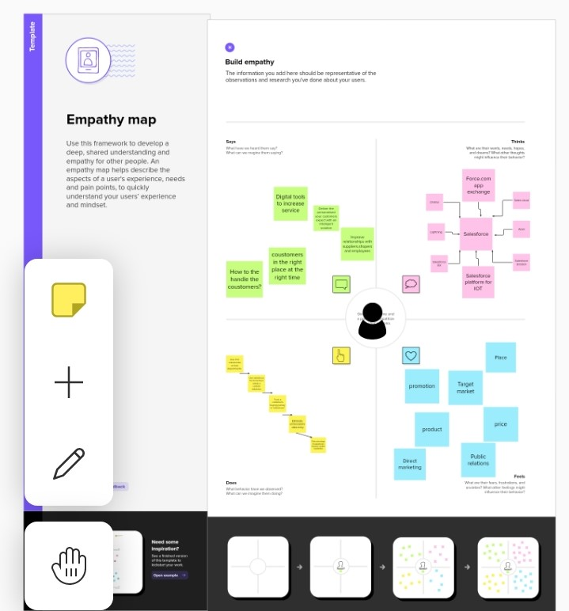

**2.2 Ideation and Brainstorming map screenshot:-**

s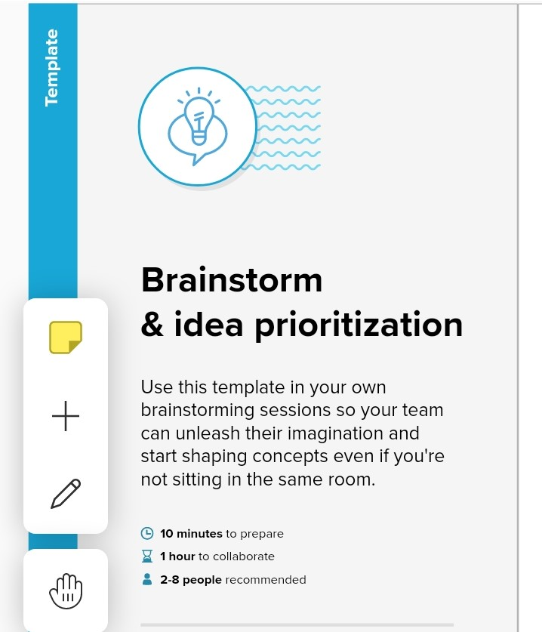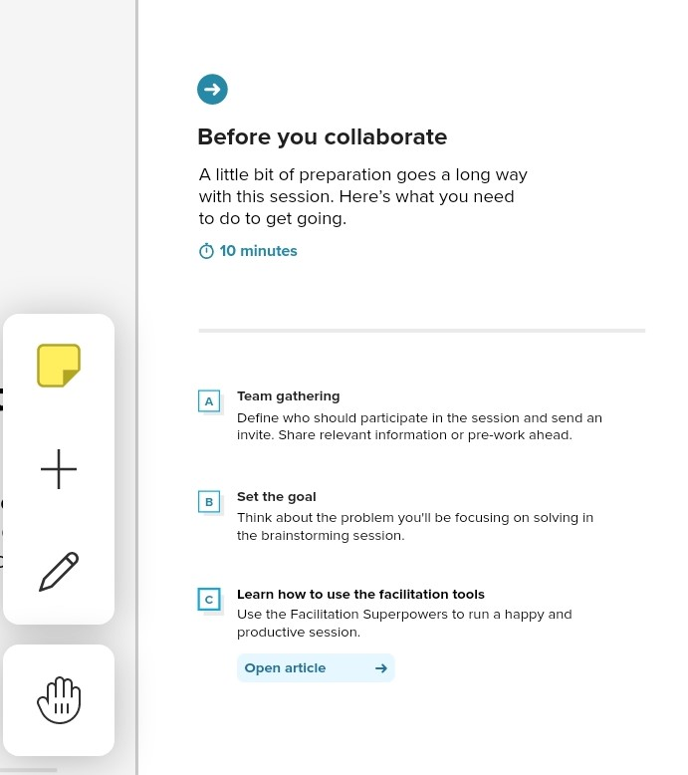

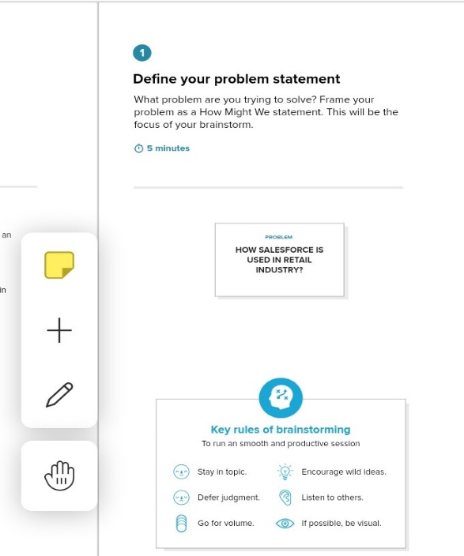

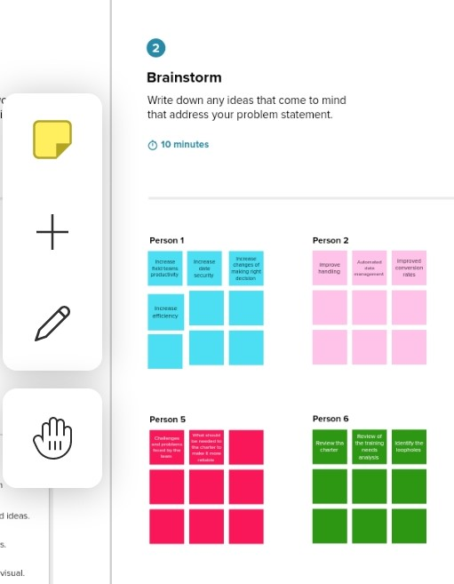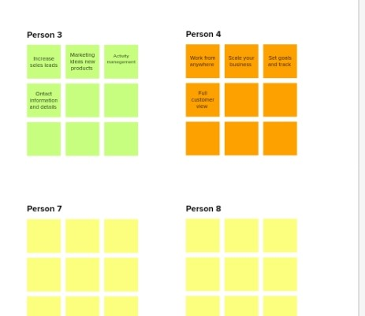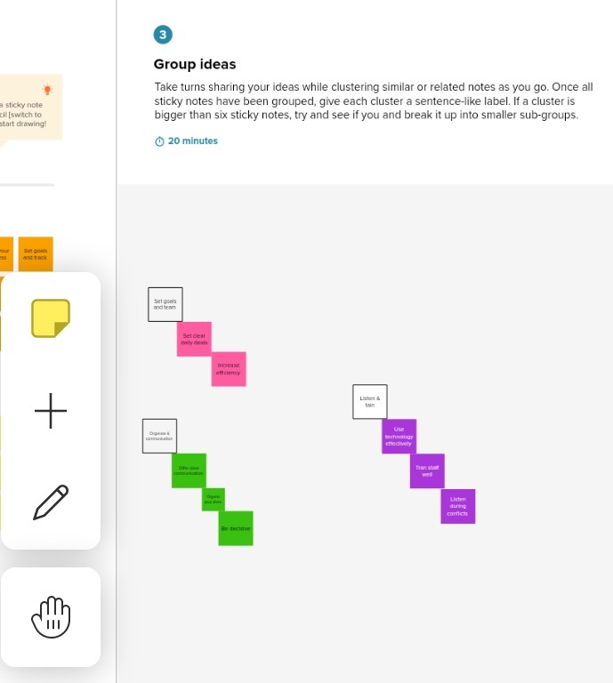

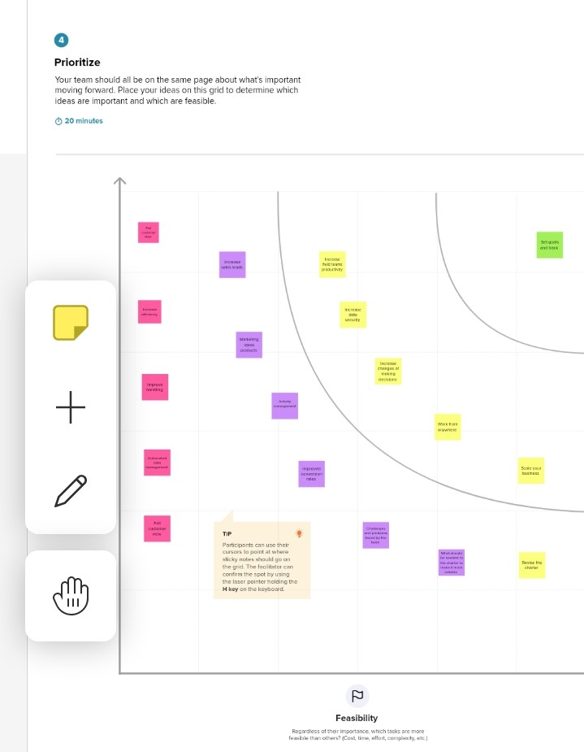

3.RESULT:-

3.1Data Modal:-

|  |  |
| --- | --- |
| Object name | Fields in the object |
| Object-1 | Field Lable:Display/ tracking  Data Type:Text |
| Object-2 | Field Lable:Dispatched  Data Type:Checkbox |

**3.2 Activity and Screenshot:-**

1.Create Developer Account

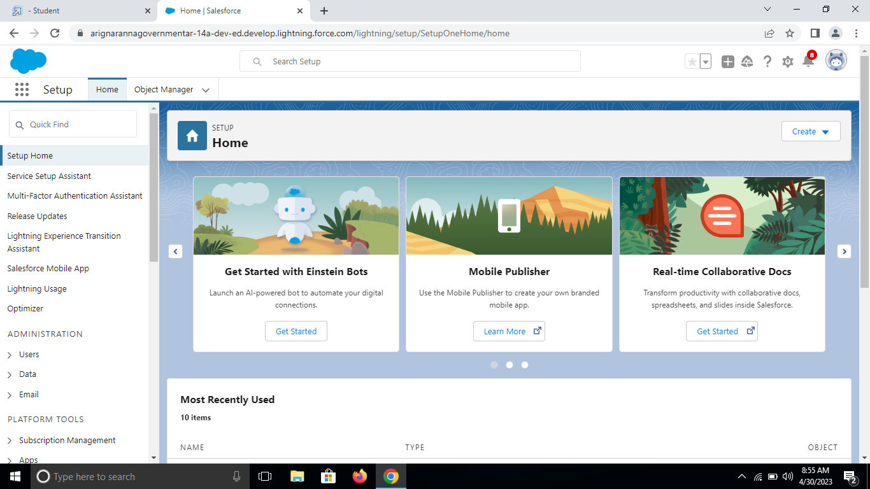

**2.Objects**

I. Creation Of Object Dispatch/Tracking

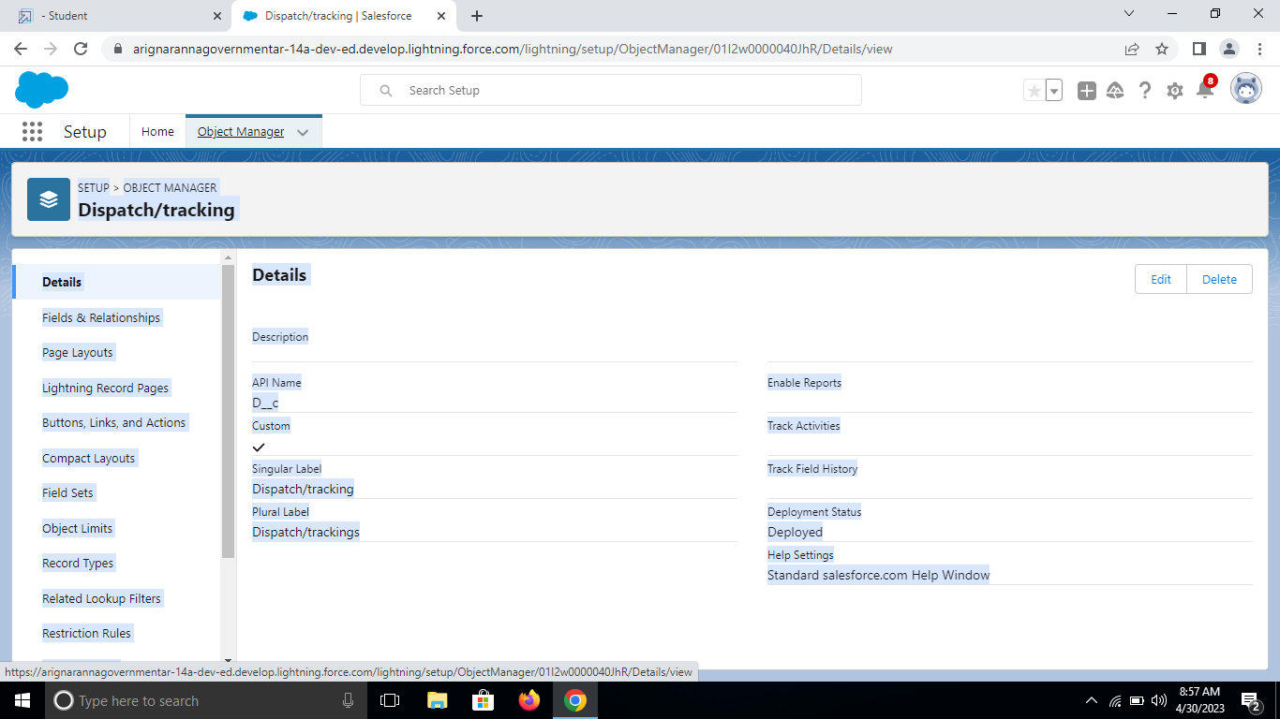

II. Fields Available On Dispatch/Tracking

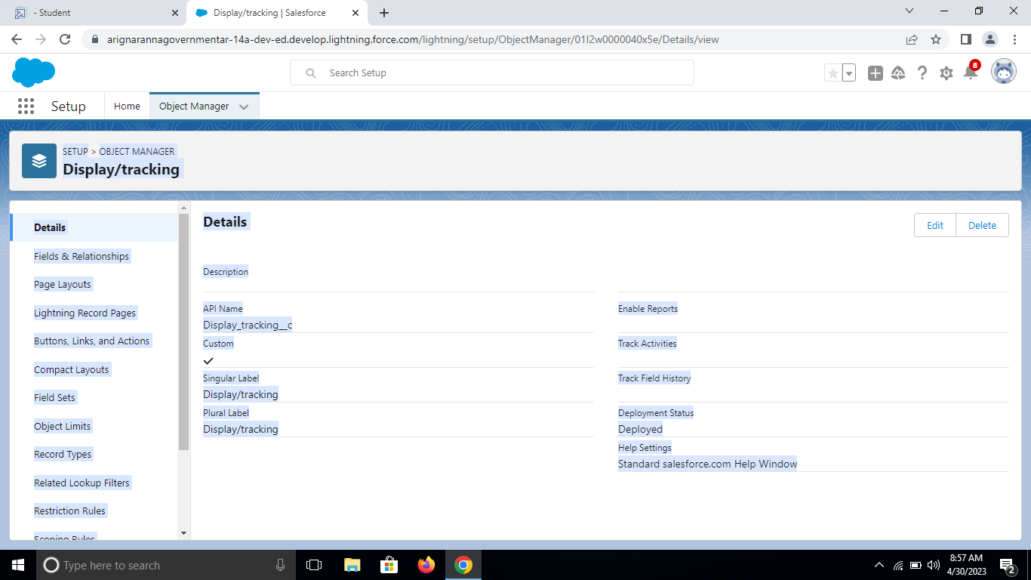

**3.Relationship B/W Objects**

I. Creation of Relationships Between Objects

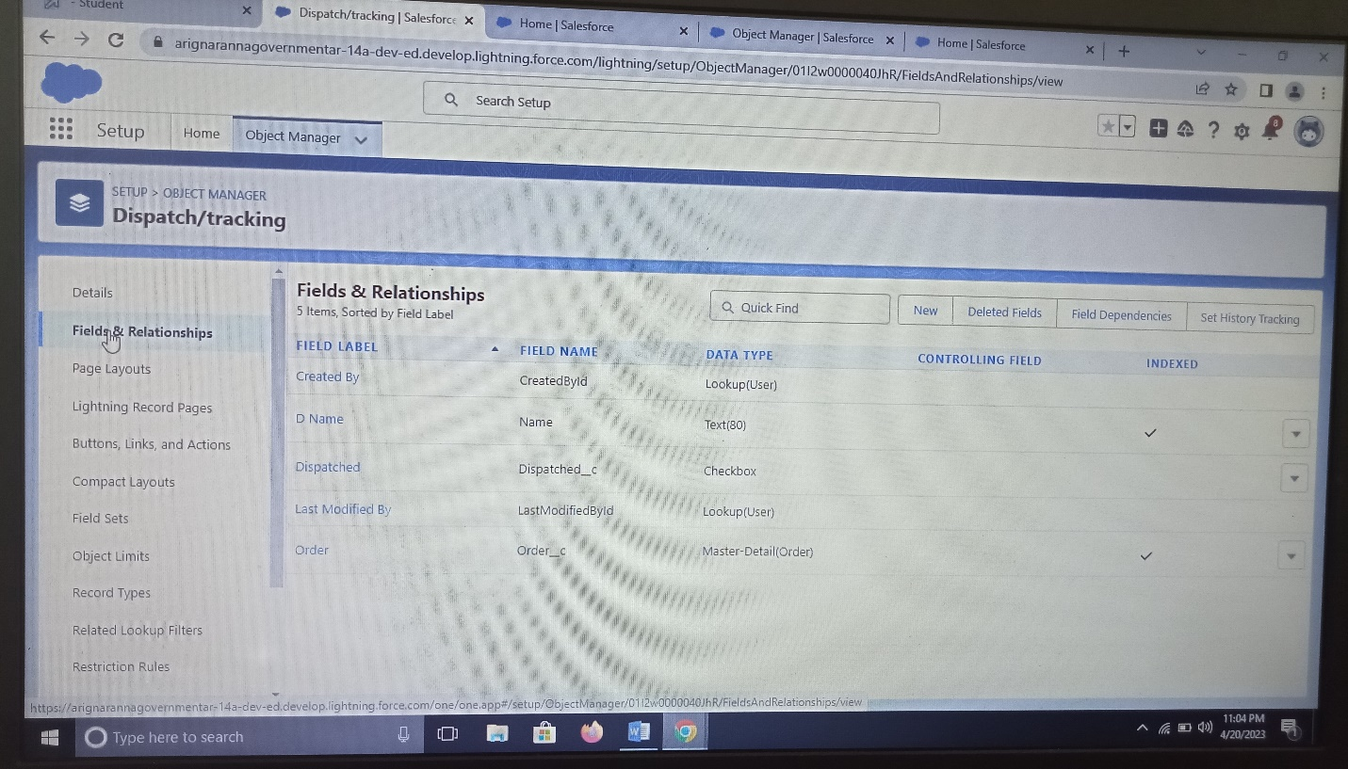

**4. Application**

I. Creation Of Application

**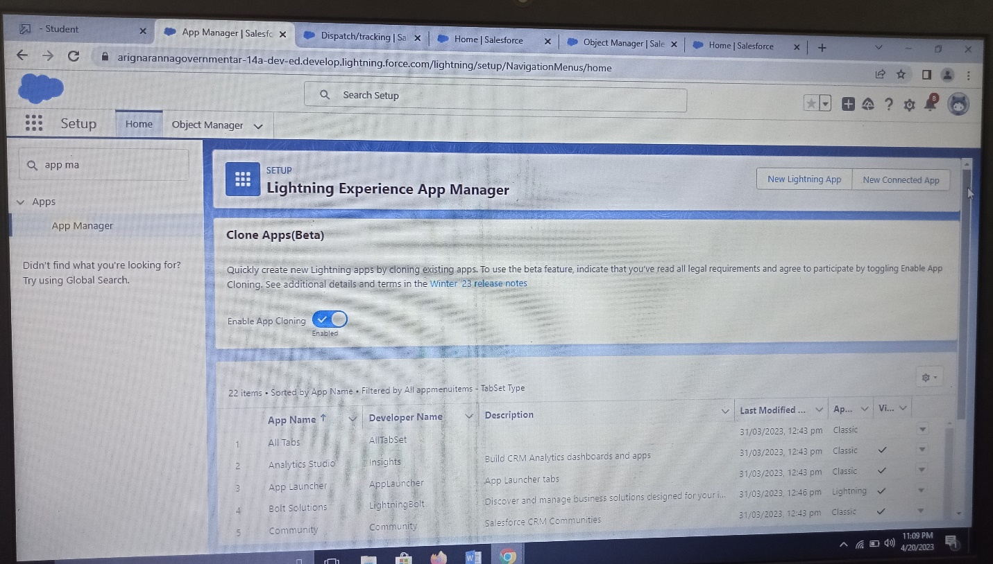  
5. Layouts**

I.Creation Of Custom Tabs

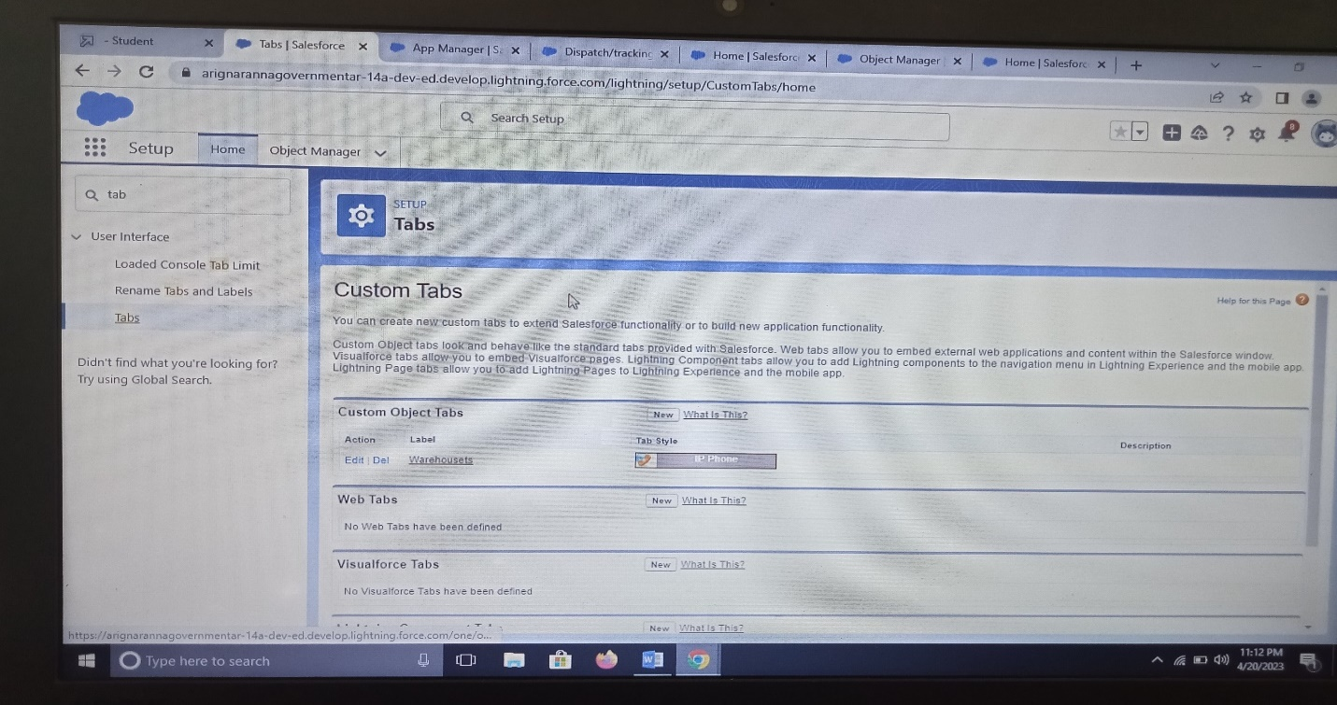

**6. User**

I. Creation Of User

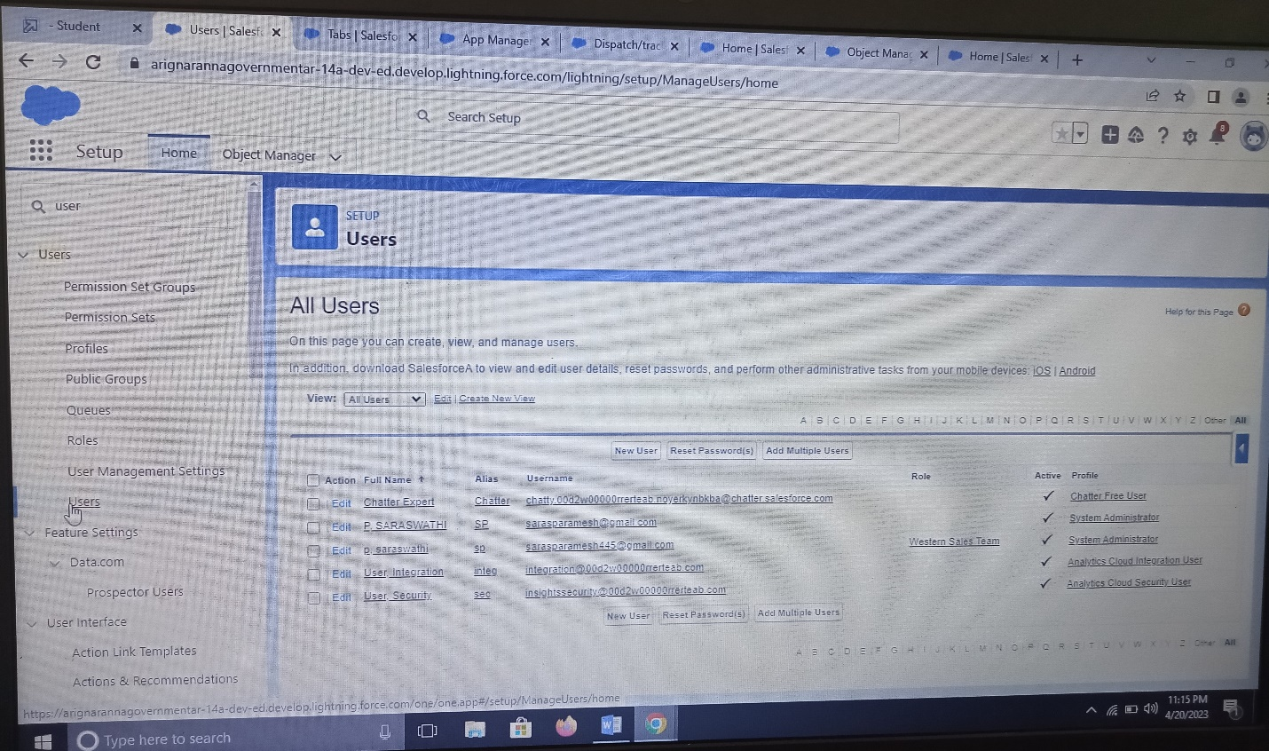

**7. Validation Rules**

I. Creation Of Validation Rule

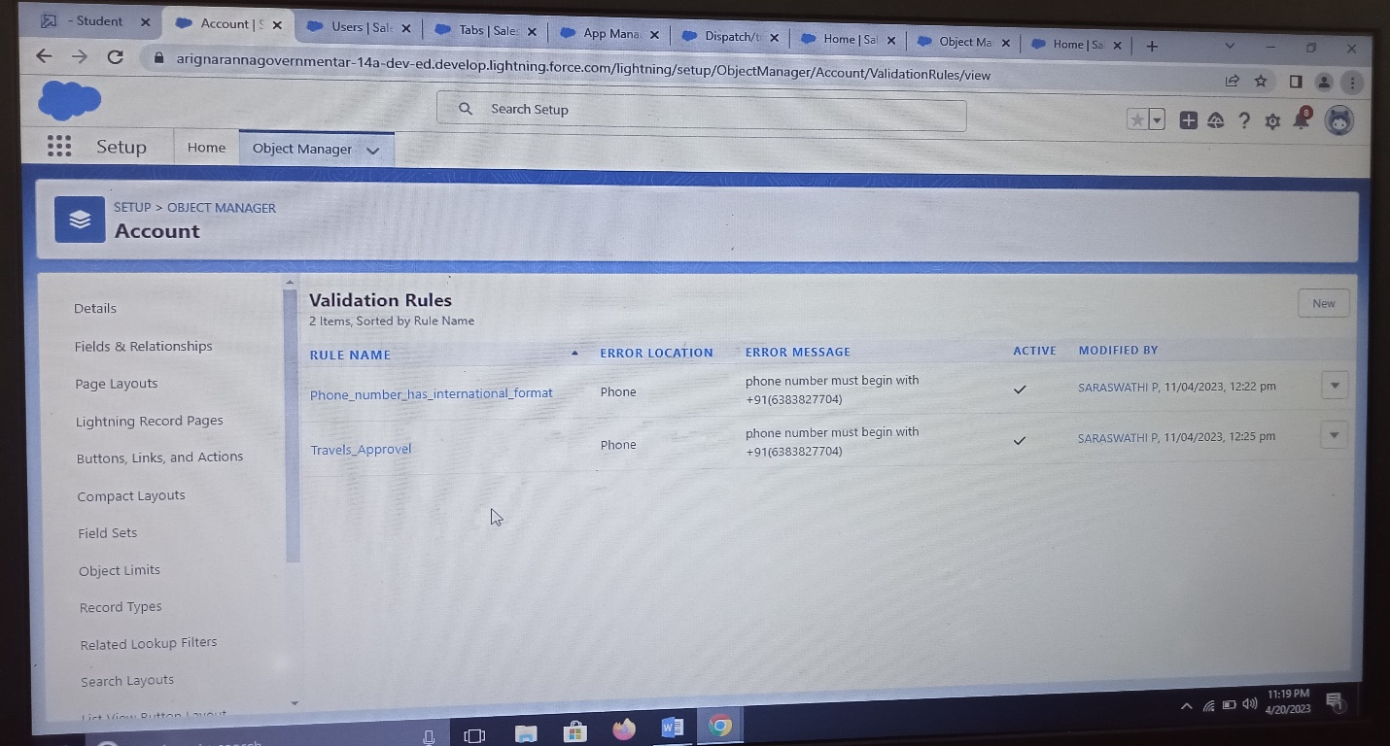

II. Creation Of Cross Object

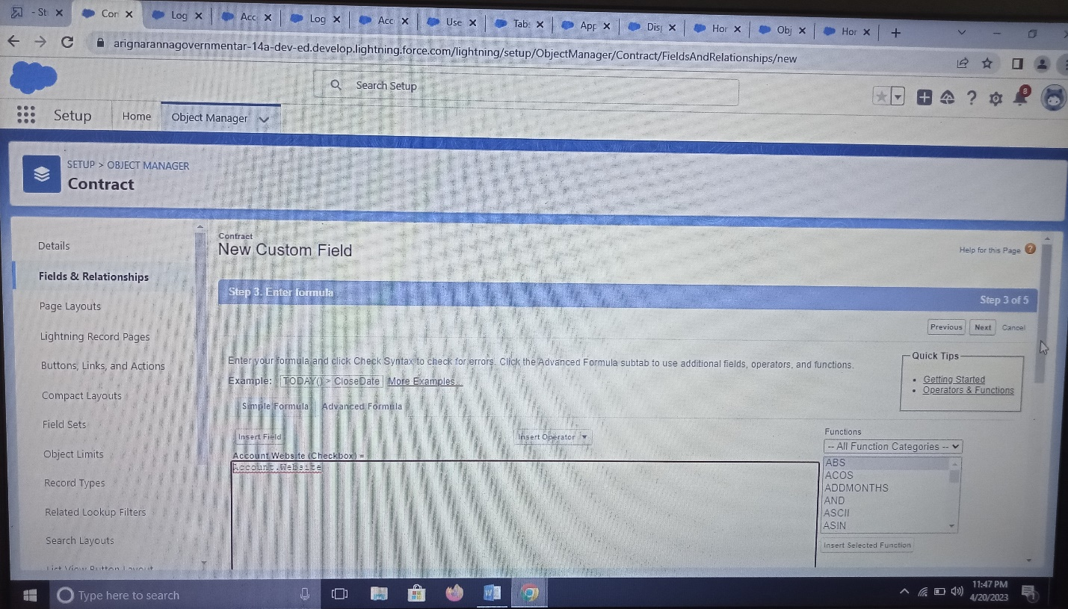

**8. Reports**

I. Creation Of Report

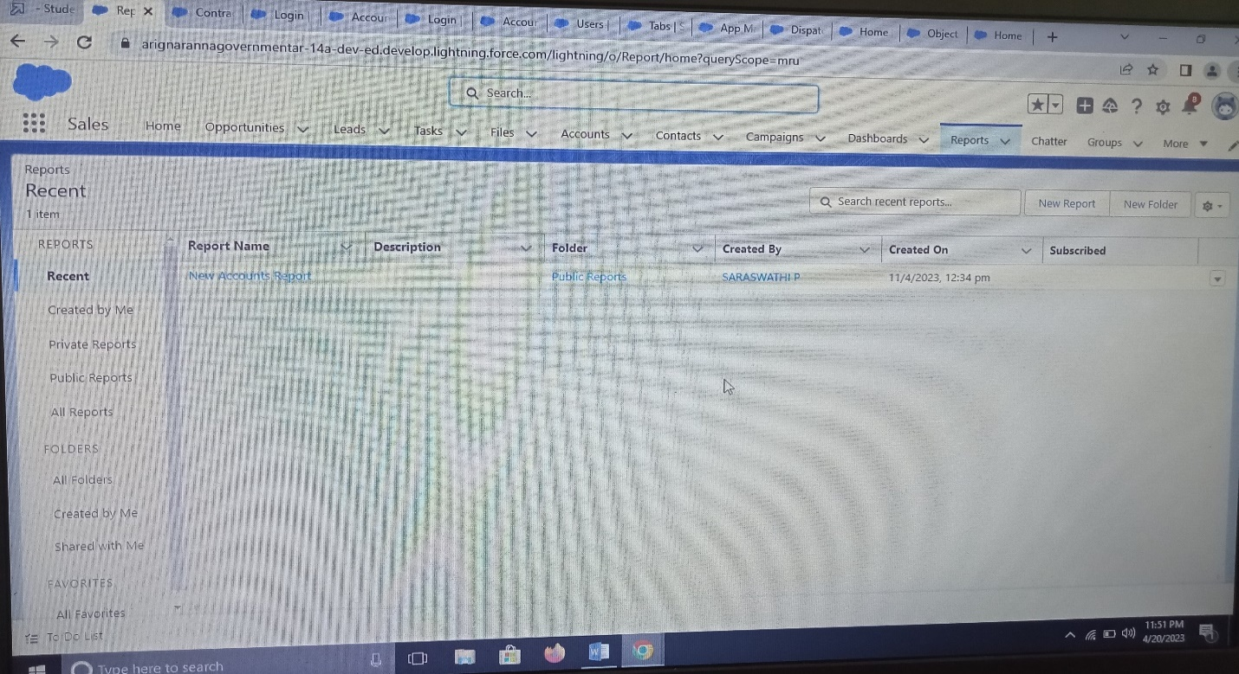

**9. Dashboards**

I. Creation Of Dashboards

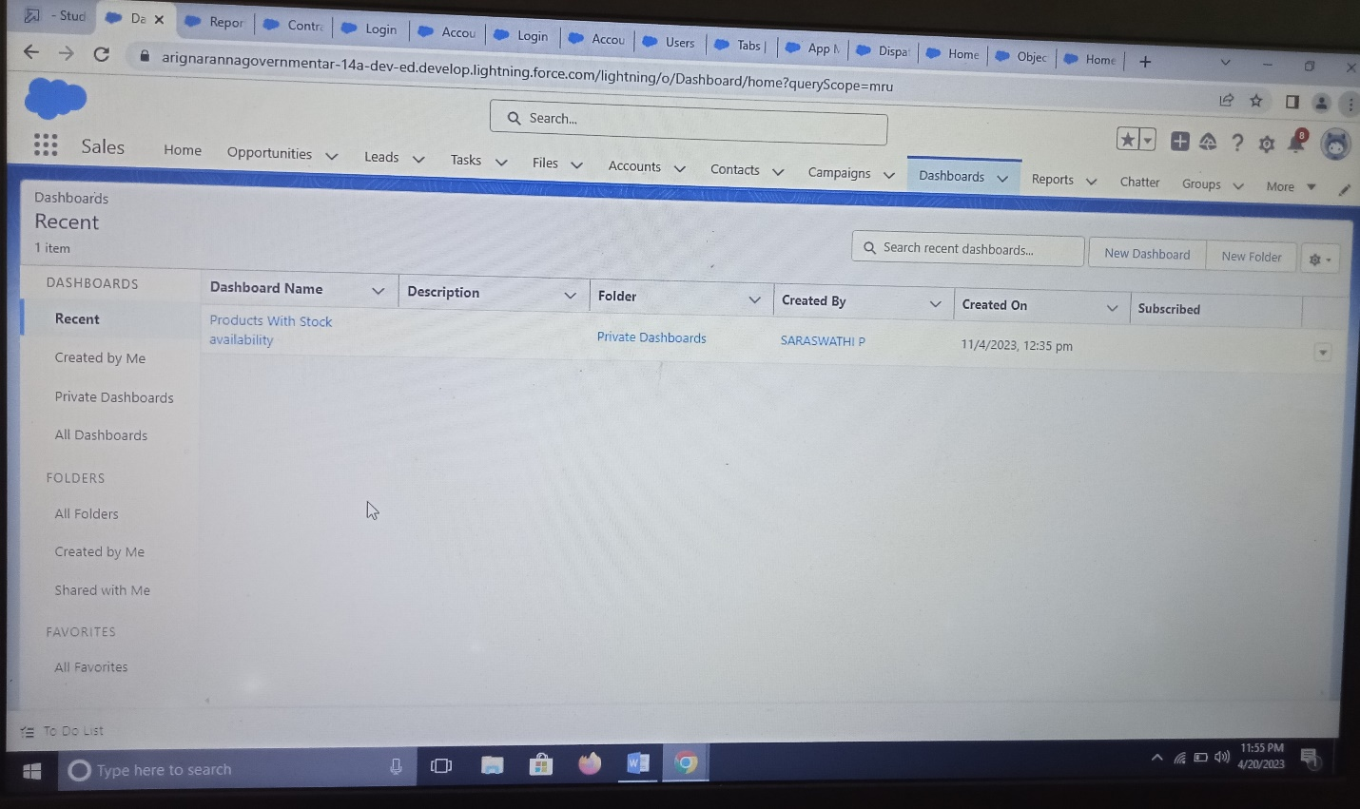

**4.Trailhead Profile Public URL**

**Team Lead-https://trailblazer.me/id/sphysics4**

**Team member 1-https://trailblazer.me/id/swathi464**

**Team member 2-https://trailblazer.me/id/ssarguna1**

**Team member 3-https://trailblazer.me/id/shari609**

**5. ADVANTAGES & DISADVANTAGES**

**1. Customization**

**Advantages**

Salesforce is designed to not only provide a significant number of features out of the box, but is also highly customizable. Using point-and-click tools, built-in UI/UX features, and automation, Salesforce can quickly be tailored and implemented to meet many use cases, streamline business process, and help organizations become more efficient. But the platform also supports complex code, integrations with other systems, and much more.

**Disadvantages**

With such a flexible, customizable platform, it can be easy to build in too much customization, and some integrations come with limitations. Additionally, it can be easy for organizations taking on new implementations to try to do too much, too soon, overwhelming users with too many features and processes to learn and fully utilize. Working with an implementation partner like Higher Echelon can help your organization determine how to prioritize needs and get the most out of your Salesforce org at a pace and level of customization that is most effective.

**2. Cloud-Based Functionality**

**Advantages**

Implementing cloud-based solutions is all the rage these days, and with good reason. CRMs that run on physical, on-site servers can limit connectivity and make it difficult for employees to access company data off site in a secure manner. Salesforce runs on the cloud, meaning that it operates out of data centers available to users over the internet. Cloud-native software provides more flexibility and accessibility to users and makes it easier to scale to support a growing team. As a result, organizations gain access to on-demand computing resources and can optimize business without worrying about provisioning and maintaining physical infrastructure.

**Disadvantages**

Generally, though there are tools available to help address specific needs, accessing a cloud-based tool like Salesforce requires an internet connection. For physical locations without the internet or a stable connection, accessing resources can be challenging.

**3. Salesforce Technical and Training Support**

**Advantages**

Salesforce provides multiple avenues for users and organizations to get help, skill up, and learn from each other. The [Trailblazer Community](https://trailhead.salesforce.com/en/trailblazercommunity) provides opportunities to ask questions related to everything from how to use a specific feature to how to create new fields, write formulas, and build automation. Community events provide ways for Salesforce customers, consultants, and more to connect. [Trailhead](https://trailhead.salesforce.com/en/trailblazercommunity) provides self-guided learning opportunities for everyone from absolute beginners to seasoned Salesforce pros, along with recognized credentials.

**Disadvantages**

As is the case with any technology implementation, problems can arise. Although Salesforce provides a dedicated support team, automated technical services can fail to resolve issues quickly, and it can take time to reach person to provide the answers you need. This delayed support can impact organizational efficiency. However, Salesforce implementation partners like Higher Echelon have experts at the ready to handle technical issues on your behalf.

**4. Overall Cost and Pricing**

**Advantages**

The Salesforce pricing model allows organizations to pay per license, ensuring the correct number of licenses can be purchased, maintained, and scaled. Additionally, licenses aren’t one-size-fits-all; different license types provide flexibility based on the access and features different users need to have available.

**Disadvantages**

Although Salesforce has a wide range of capabilities and offers a scalable pricing model, additional users come with an additional cost, as does ongoing customization, particularly if code is involved. This can lead to higher costs compared to other CRMs. However, partnering with a [Salesforce implementation](https://www.higherechelon.com/salesforce-implementation-services/) specialist can help your organization identify cost-effective, long-term solutions to optimize your investment.

**5. Many Products for Many Organizational Needs**

**Advantages**

Salesforce is much more than a sales tool, and much more than a CRM. From sales to service, marketing to commerce, analytics to integration, even sustainability, there’s just about guaranteed to be a [Salesforce product](https://www.salesforce.com/products/#products-scroll-tab) that meets any use case in any industry.  And then, there’s the AppExchange, allowing companies to build and share their own apps built on the Salesforce platform.

**Disadvantages**

While Salesforce has a wide range of functionalities and tools that businesses can use, it can be challenging and time-consuming to choose the right tools and implement Salesforce without help. To save time and streamline the implementation process, it is best to trust a Salesforce specialist who understands the ins and outs of the platform.

**APPLICATION**

**Unify marketing, commerce, service, and IT data on one connected retail platform.**

**Engage customers, win loyalty, and support associates**

Unlock collaboration across teams on a single, integrated platform. Transform your retail business fast and improve relationships with suppliers, shoppers, and employees.

**Use Commerce Cloud to turn shoppers into buyers, faster**

Deliver seamless buying and service experiences across all channels by engaging with customers in the right place, at the right time.

**Personalise every path-to-purchase with Marketing Cloud**

Win new customers and earn lifelong loyalty by using your data to provide personalised engagements.

**Reimagine the role of the sales assistant**

Change how you serve customers by supporting your retail staff with digital tools to increase efficiency and improve service.

**House of Anita Dongre designs seamless omni-channel shopping experiences with Salesforce**

House of Anita Dongre stitches together online and offline customer data into a single view, enabling targeted marketing, engaging ecommerce, and faster service.

**CONCLUSION**

Customer Engagement: Salesforce provides a unified platform for managing customer interactions, which enables retailers to deliver personalized shopping experiences. With features like Einstein AI and Live Agent, retailers can provide real-time assistance and support to customers, resulting in increased customer loyalty.

Data Management: Salesforce provides a centralized repository for managing customer, product, and sales data. Retailers can easily access and analyze this data to make informed business decisions, such as optimizing pricing and product placement.

Inventory Management: Salesforce integrates with leading e-commerce platforms and point-of-sale (POS) systems, making it easy for retailers to manage their inventory and ensure that products are always in stock. With real-time inventory updates, retailers can make better decisions about restocking and order fulfillment.

**FUTURE SCOPE**

The future of Salesforce looks bright as the demand for Salesforce professionals continues to grow. With the increasing adoption of cloud technology and the growth of customer relationship management (CRM) systems, there will be a growing need for Salesforce expertise in the coming years.

In addition, the company is constantly innovating and adding new features and capabilities to its platform, which will create new job opportunities and career paths for those trained in Salesforce. As more companies turn to Salesforce to manage customer interactions, it's likely that the demand for Salesforce experts will only increase. Therefore, learning Salesforce can be a smart career move for individuals looking for a lucrative and stable career in the technology field.

So, if you want to learn salesforce for free then you must go for Intellipaat’s salesforce video training which would definitely help you to learn the salesforce fundamentals in the best and effective manner.